** **

**3rd National Conference for Quality and Sustainable Development**

2024 / 11/25-26

A form for writing a research paper in English

Headline search (font 14) Times New Roman

First name 1, second name 2, third name 3

1 Scientific authority, city, country

2 The scientific body, city, country

3 Scientific authority, city, country

E-mail

**Abstract:** The abstract should be written using MSWord, Times New Roman style, font size 12 and headings 14, line spacing 1.5, on A4 size paper, page margins 2.5 cm on each side, it is recommended using this form when writing the research papers that the researcher intends to present at the conference.

The researcher must follow the technical instructions carefully, and scientific papers in the form other than that are not accepted. The abstract should also contain the subject of the study, its justifications and objectives, the methodology used, the cases of the study, the most important results. The number of words in the abstract should not exceed 300 words, and the number of pages for the entire paper should not exceed 12 pages, including figures, references and tables. Figures and tables should be placed in the middle of the page, provided that the numbers and titles of the figures are at the bottom, while the numbers and titles of the tables are at the top, with the necessity of sequencing the numbering of figures and tables, according to their appearance in the research, as shown in Table (1) and Figure (1) below.

**Key words:** Remember keywords that refer to the research paper between 5-7 introductory words with commas (for example: Heavy metals, cadmium, lead, mercury, tuna...

Table (1): The amount of some heavy metals in local tuna, mg / kg (parts per billion).

|  |  |  |  |
| --- | --- | --- | --- |
| Samples | Cd ppb | Pb ppb | Hg ppb |
| Sample 1 | 155 | 200 | 112 |
| Sample 1 | 270 | 345 | 213 |
| Sample 3 | 120 | 145 | 310 |
| Sample 4 | 234 | 672 | 225 |
| Sample 5 | 250 | 345 | 348 |
| Sample 6 | 450 | 219 | 158 |

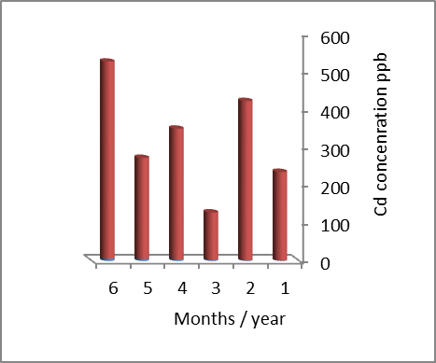

Figure (1): the amount of lead in samples during some months of the year.

The research paper should be written in good English and checked and reviewed for grammar and spelling mistakes before submitting it. When writing references inside the paper, it must be in the form shown in the references section. The list of references should be at the end of the paper in alphabetical order. The main structure of the research paper should also contain the following headings: Abstract, introduction, materials, and methods of research or methodology, results and discussion or findings, conclusions, recommendations and references.

1. **Introduction**

The introduction must contain a theoretical description of the research problem and the related research, agreement and opposition to the researcher's opinion. The introduction should explain the main purpose of the research, and it is very important that the main objectives or hypotheses to be clearly defined.

1. **Research materials and methods or methodology**

The practical side or the methodology should be explained, how to use measurement techniques, methods and devices, or mathematical statistics, data collection techniques, samples, their number, experiments, programs used, and other means of preparation, taking into account should be written in scientific way.

1. **Results, discussion**

This part of the research should present the results of experiments, questionnaires, or other scientific tools used in the research or study in the form of tables, figures, or pictures, with their explanations in a clear and direct way. In addition, the researcher must discuss these results in a scientific way by providing scientific and logical explanations. Comparing results with previous studies should take place.Also presenting the implications of such results.

1. **Conclusion and recommendations**

This part clarifies the important results of the study or research and mentions the most important simplified recommendations that can be drawn up based on the data have been presented. Possible future applications can also be mentioned.

1. **References**

The process of documenting the reference in the text depends on the number of authors in it and the place of reference to it in the text. If the author of the reference is one person and his name is mentioned at the beginning of the sentence or text, his last name is written only, then year of publication. If two persons published the paper, last name of each of followed by the year, but if more than two people participated in writing it, then only the title of the first writer is written, followed by a word and others, followed by the year of publication.

Remember the references that were used in the body of the research paper, should be arranged as it shown in the text as follows:

First Author; Second Author; Third Author; etc. Year. Paper Title. Journal Name, Issue, Volume Number, Page Numbers.

Alhwaige, A. A.; Ishida, H.; and Agag, T.; 2015. Physical and Chemical Characteristics of Marine Green Algae. Journal of Food Science and Technology. (3) 2: 215-222.

Ishida, H.; Agag, T. 2019. Handbook of Benzoxazine Resins. Elsevier, Amsterdam. Chapter 1, pp. 1–83.

First Name, Second Name, Third Name, etc. the Year. Title of the Article or Research. Publishing House Address, Issue, Volume, Page Numbers.